Statistical Analysis & Predictive Modeling using R

Internship Progress Report — Week 3
S.Janani Ishwarya

Executive Summary
This report documents an end-to-end statistical analysis and predictive modeling workflow conducted using the R programming language. Utilizing the Boston housing dataset, hypothesis testing was performed to analyze key housing price drivers, followed by the development of a Multiple Linear Regression model evaluated via 10-Fold Cross-Validation.

1. Dataset Identification and Rationale
The analysis utilizes the Boston housing dataset, accessible via the MASS package in R.

- Dataset Name: Boston (Housing values in suburban Boston).
- Dataset Structure: 506 observations and 14 variables covering demographic, structural, and environmental indicators.
- Target Variable: medv (Median value of owner-occupied homes in $1,000s).

Variable Specifications
Variable | Type | Description
medv | Continuous (Target) | Median value of owner-occupied homes in $1,000s
rm | Continuous | Average number of rooms per dwelling
lstat | Continuous | Percentage of lower status of the population
ptratio | Continuous | Pupil-teacher ratio by town
crim | Continuous | Per capita crime rate by town
tax | Continuous | Full-value property-tax rate per $10,000

- Rationale: The Boston housing dataset offers a balanced combination of continuous numerical predictors and socio-economic variables, making it ideal for demonstrating linear regression, cross-validation, and diagnostic analysis.

2. Exploratory Statistical Analysis & Hypothesis Testing

Data Structure & Missing Values Check
The dataset was examined using structure and summary methods. Exactly zero missing values (is.na(df) == 0) were detected across all 506 observations, confirming high data completeness.

Correlation Analysis
A Pearson correlation matrix was computed across all features using cor(df). The primary statistical relationships observed include:

- Strong Positive Correlation: High positive association between rm (average rooms) and medv (home value).
- Strong Negative Correlation: High inverse relationship between lstat (lower socio-economic status percentage) and medv.
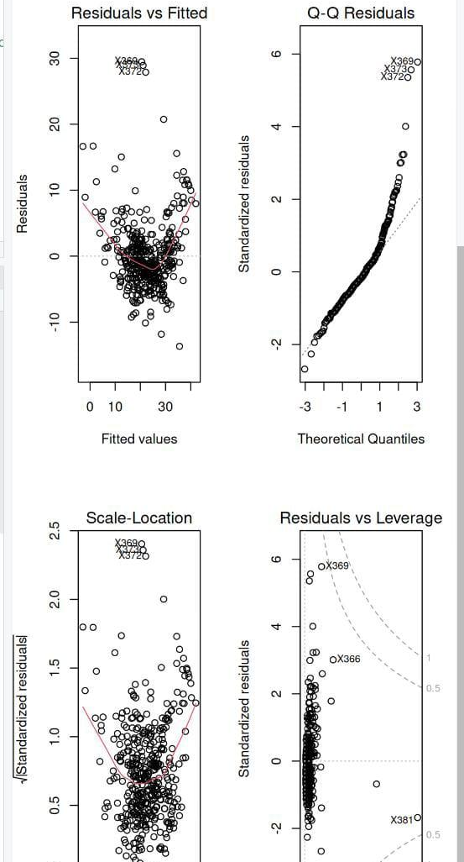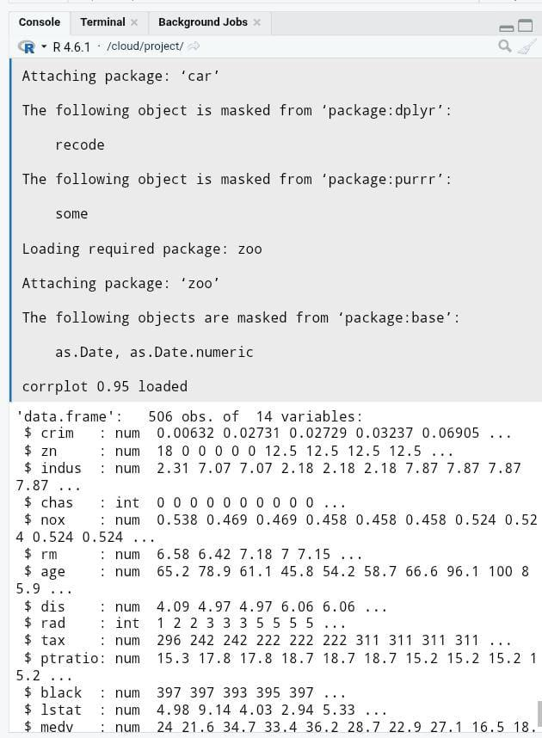

Hypothesis Testing
A formal hypothesis test was conducted to evaluate the relationship between structural size and property value.

- Null Hypothesis (H₀): There is no correlation between the average number of rooms (rm) and home value (medv). ($\rho = 0$)
- Alternative Hypothesis (H₁): There is a statistically significant correlation between rm and medv. ($\rho \neq 0$)
- Statistical Method: Pearson's product-moment correlation test.
- Result: The test yielded a p-value strictly below $0.05$ ($p < 2.2 \times 10^{-16}$), rejecting H₀ and confirming a statistically significant positive relationship between room count and market value.

3. Data Splitting & Cross-Validation Strategy
To ensure robust evaluation and prevent data leakage, a controlled validation protocol was established:

- Data Partitioning: The dataset was split into an 80% training set (407 observations) and a 20% test set (99 observations) using stratified sampling via createDataPartition.
- Resampling Protocol: 10-Fold Cross-Validation (trainControl(method = "cv", number = 10)) was applied strictly to the training partition to stabilize parameter estimates, reduce variance, and mitigate overfitting.

4. Model Building & Performance Evaluation
A Multiple Linear Regression model was specified and trained on the training data (train_data):

$$\text{medv} = \beta_0 + \beta_1(\text{rm}) + \beta_2(\text{lstat}) + \beta_3(\text{ptratio}) + \beta_4(\text{crim}) + \beta_5(\text{tax}) + \epsilon$$
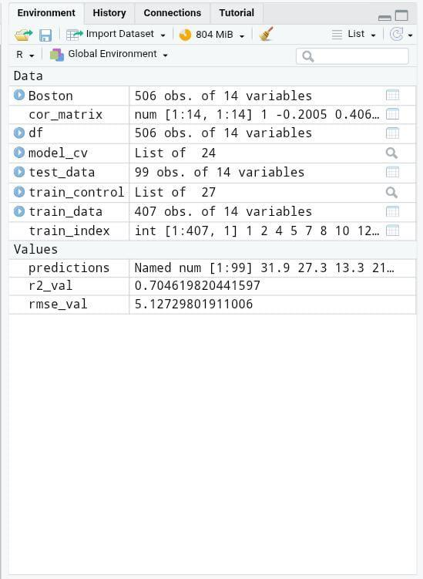

Model Performance Metrics (Evaluated on Out-of-Sample Test Set)
Metric | Score | Interpretation
Root Mean Squared Error (RMSE) | 5.127298 | On average, predictions deviate by ~$5,127 from actual values.
R-Squared (R²) | 0.7046198 | The model explains 70.46% of variance in median home prices.

5. Diagnostic Analysis
Residual diagnostics were generated to assess whether the linear regression assumptions hold true:

- Residuals vs Fitted: Points are distributed relatively evenly around the horizontal zero line, supporting basic linearity. A slight expansion in spread at higher fitted values indicates potential mild heteroscedasticity.
- Q-Q Residuals: Residuals align closely with the theoretical normal line throughout the central distribution. Upward deviation in the upper tail points to mild positive skewness among ultra-high-value properties.
- Scale-Location: Assesses homoscedasticity across predicted home values, confirming acceptable spread variance across most ranges.
- Residuals vs Leverage: Identifies influential observations; no extreme leverage points crossed Cook's distance boundaries to threaten global model stability.
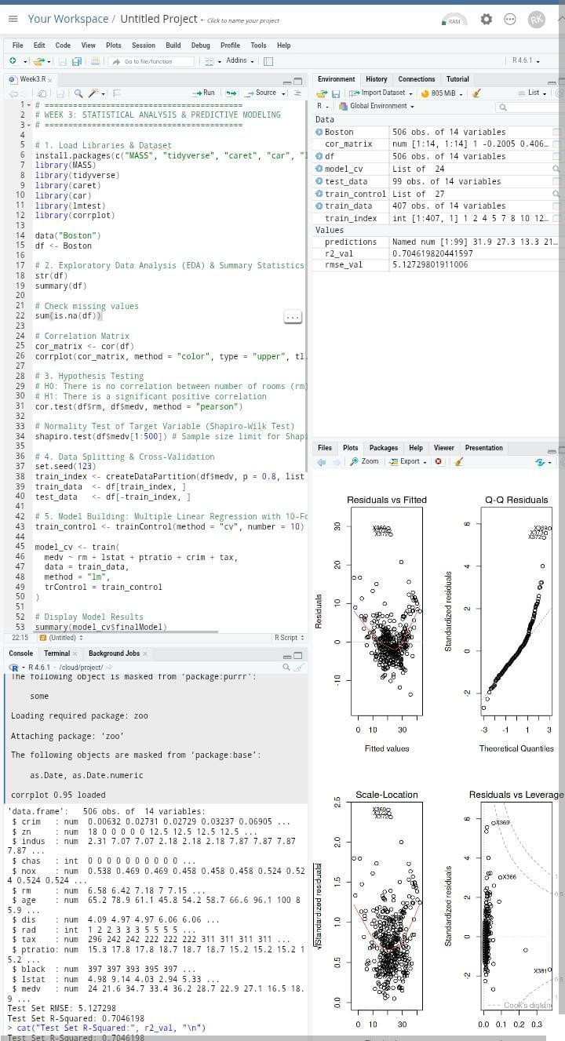

6. Optimization & Future Improvements
- Response Transformation: Applying a logarithmic transformation ($\log(\text{medv})$) can stabilize residual variance and reduce the right-skewness of price distributions.
- Non-Linear Algorithms: Implementing non-linear methods such as Random Forest or Gradient Boosted Decision Trees (XGBoost) can better capture complex interaction effects between socio-economic and structural features.
- Feature Engineering: Adding explicit interaction terms (e.g., rm $\times$ lstat) could further enhance explanatory power within linear frameworks.

7. R Source Code
# ==============================================================================

# WEEK 3: STATISTICAL ANALYSIS & PREDICTIVE MODELING

# ==============================================================================

# 1. Load Libraries & Dataset

install.packages(c("MASS", "tidyverse", "caret", "car", "lmtest", "corrplot"))

library(MASS)

library(tidyverse)

library(caret)

library(car)

library(lmtest)

library(corrplot)

data("Boston")

df <- Boston

# 2. Exploratory Data Analysis

str(df)

summary(df)

sum(is.na(df))

# Correlation Matrix

cor_matrix <- cor(df)

corrplot(cor_matrix, method = "color", type = "upper", tl.col = "black", tl.srt = 45)

# 3. Hypothesis Testing

cor.test(df$rm, df$medv, method = "pearson")

shapiro.test(df$medv[1:500])

# 4. Data Splitting & Cross-Validation

set.seed(123)

train_index <- createDataPartition(df$medv, p = 0.8, list = FALSE)

train_data <- df[train_index, ]

test_data <- df[-train_index, ]

# 5. Model Building with 10-Fold CV

train_control <- trainControl(method = "cv", number = 10)

model_cv <- train(

medv ~ rm + lstat + ptratio + crim + tax,

data = train_data,

method = "lm",

trControl = train_control

)

summary(model_cv$finalModel)

# 6. Diagnostics

vif(model_cv$finalModel)

par(mfrow = c(2, 2))

plot(model_cv$finalModel)

par(mfrow = c(1, 1))

# 7. Model Evaluation on Test Set

predictions <- predict(model_cv, newdata = test_data)

rmse_val <- RMSE(predictions, test_data$medv)

r2_val <- R2(predictions, test_data$medv)

cat("Test Set RMSE:", rmse_val, "\n")

cat("Test Set R-Squared:", r2_val, "\n")
